Ride With Me

Project Plan

Prepared by: Sebastian Alvarado

cheviz@gmail.com

Version 1.3

July 11, 2014

Document History and Distribution

Revision History

|  |  |  |  |
| --- | --- | --- | --- |
| Revision # | Revision Date | **Description of Change** | **Author** |
| 1.0 | 2014 07 09 | Initial Document | Sebastian Alvarado |
| 1.1 | 2014 07 10 | Team Structure  Technical overview |
| 1.2 | 2014 07 11 | Project Overview  Update Plan  Definitions |

Definitions and Acronyms

|  |  |
| --- | --- |
| Term | Definition |
| BRD | Business Requirements Document |
| TL | Technical Lead |
| PM | Project Manager |
| ST | Software Tester |
| SA | System Administrator |
| SE | Software Engineer |
| BA | Business Analyst |
| IDE | Integrated Development Environment |
| JSON | JavaScript Object Notation) is a lightweight data-interchange format. |
| DBMS | Data Base Management System |

### Project Overview

People need to move from one point to another within a city in a quick, safe and affordable way. This created the need for more vehicles or an efficient way to manage the existing fleet. Traffic jams and the excessive number of vehicles make it impractical to add more cars to an already saturated road network.

For this project, we will focus on how to improve the performance of the fleet. Cars with empty seats move around a city all the time, wasting time, space and fuel. We strongly believe that, by giving drivers the ability to connect with people looking for a ride we can improve the way people move around.

### Scope

To design and develop the RIDE WITH ME application and backing systems, the following tasks must be completed:

* Comply with 100% of the functions described in the business requirements documents (BRD) approved and reviews by all the relevant members of the team.
* Design and build an efficient and system, capable of satisfying user demands.
* Deliver clear, easy to use and efficient applications for our users (passengers and drivers).

### Function List

The following tables details the different function that must be implemented in our system.

Table 1. Function list for the administrator role

|  |  |  |  |
| --- | --- | --- | --- |
| Role | Component | Page | Function |
| Admin | Website | Login | Login |
| Driver | Add |
| Update |
| Remove |
| View |
| Passenger | Update |
| Remove |
| View |

Table 2. Function list for the driver role

|  |  |  |  |
| --- | --- | --- | --- |
| Role | Component | Page | Function |
| Driver | Driver  Application | Login | Login |
| Search Passenger | Search for Passenger |
| Bid for Book |
| Pick Up | Pick Up Passenger |
| Drop | Drop Passenger |
| Passenger Review | View Payment Notification |
| Rate the Passenger |

Table 3. Function list for the passenger role

|  |  |  |  |
| --- | --- | --- | --- |
| Role | Component | Page | Function |
| User | Passenger  Application | Sign Up | Sign Up |
| Login | Login |
| Pick Me Up | Pick The Passenger |
| Book A Ride | Book A Ride |
| Select Booking Option | Choose Car |
| Hurry Up | Alert the driver to arrive faster |
| Driver Review | View Payment Notification |
| Rate The Driver |

### Technical Overview

The project consists of four modules, a server, two android applications (for the driver and the passenger) and an admin web interface.

* **Android Applications:**  For this component of the system, basic android technologies will be used. The IDE we are going to use to develop the applications is Android Studio. Due to their similarity, the driver and passenger applications will be developed concurrently.
* **Admin Webpage:** This component is a simple webpage, it will be developed using HTML and CSS in Notepad++.
* **Server:** The backend of the service will be developed using JAVA EE technologies, together with the Apache Tomcat Server as host and MySQL as the DBMS.

It’s important to note that the communication between the server and the different clients will be done by using HTTP and JSON.

### TEAM STRUCTURE

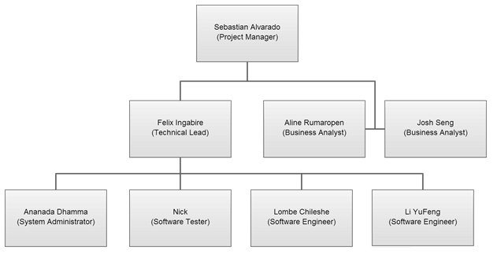

### Project Management Plan Updates

Software development is a dynamic field, changes in requirements or designs might happen at any moment. Therefore, good procedures must exist to update all the relevant documentation. In such a scenario, a request must be made to the project manager, who will then consider the reasoning behind the change and the justification for a change to decide whether or not the change should be applied. If a change is approved, once the document is updated it must be submitted to peers for the purpose of review, to guarantee consistency and accuracy.